

**International School**

**Software project management**

CMU-IS 432 BIS

**Proposal Document**

**Version 1.0 Date: 23/02/2024**

GYM Master – Fitness care system

**Submitted by**

Duy, Le Hai

Vu, Nguyen thien le

Thu, Phan Nguyen Anh

Thanh, Phan Van

An, Vo Thuy

**Approved by**

Hoang, Nguyen Thai

**Proposal Review Panel Representative:**

Name Signature Date

_________________________ 23-Feb-2024

Mentor:

Name Signature Date

Hoang, Nguyen Thai _________________________ 23-Feb-2024

**Project Information**

|  |  |  |  |  |
| --- | --- | --- | --- | --- |
| **Project acronym** | GYM Master | | | |
| **Project Title** | Fitness care system website | | | |
| **Start Date** | 25th Jan 2024 | **End Date** | | 23th May 2024 |
| **Lead Institution** | International School, Duy Tan University | | | |
| **Project Mentor** | Mr. Hoang, Nguyen Thai | | | |
| **Project Manager & contact details** | Duy, Le Hai  Email: [lehaiduy2003@gmail.com](mailto:lehaiduy2003@gmail.com)  Tel: 0383007180 | | | |
| **Partner Organization** | Duy Tan University | | | |
| **Project Web URL** |  | | | |
| **Team members** | **Name** | | **Email** | **Tel** |
| 27211200940 | Duy, Le Hai | | [Lehaiduy2003@gmail.com](mailto:Lehaiduy2003@gmail.com) | 0383007180 |
| 28211235098 | Thu, Phan Nguyen Anh | | [anhthuphan0102@gmail.com](mailto:anhthuphan0102@gmail.com) | 0123456789 |
| 28211229940 | Vu, Nguyen Thien Le | | [nguyenthienlevu@gmail.com](mailto:nguyenthienlevu@gmail.com) | 0123456789 |
| 28211233669 | An, Vo Thuy | | [vothuyan234@gmail.com](mailto:vothuyan234@gmail.com) | 0123456789 |
| 28211245678 | Thanh, Phan Van | | [thanhphan334455.2@gmail.com](mailto:thanhphan334455.2@gmail.com) | 0123456789 |

**Proposal Document**

|  |  |  |  |
| --- | --- | --- | --- |
| **Document Title** | Proposal | | |
| **Reporting Period** | February, 2024 | | |
| **Author(s) & project** | Duy, Le Hai | | |
| **Role** | Vu, Nguyen Thien Le | Member |  |
| Thu, Phan Nguyen Anh | Member |  |
| An, Vo Thuy | Member |  |
| Thanh, Phan Van | Member |  |
| **Date** | 23th Feb 2024 | Filename | Proposal_v1.0 |
| **URL** |  | | |
| **Access** | Project and CMU Program | |  |

**Document History**

|  |  |  |
| --- | --- | --- |
| **Version** | **Date** | **Comments** |
| 1.0 | 23/02/2024 | Initial Release |

**Document Approvals**

The following signatures are required for approval of this document.

|  |  |  |
| --- | --- | --- |
| Mr. Hoang, Nguyen Thai  *Mentor* | Signature | Date |
| Duy, Le Hai  *Project manager* | Signature | Date |

**Table of Contents**

1 Introduction 6

1.1 Purpose 6

1.2 Scope 6

2 Project Overview 6

2.1 Project definition 6

2.2 Business needs/ User needs 6

2.3 Prior Art: 7

2.4 Project goal 8

2.5 Objectives 8

2.6 Introduction Technologies 9

2.7 System overview 10

2.7.1 System context 10

2.7.2 System context description 10

2.8 Technical Constraints 11

3 Master Plan 12

3.1 Scrum Process 12

4 Organization Management 14

4.1 Human Resource 14

4.2 Master plan 14

5 Cost Estimation 15

6 Conclusion 16

7 Project Constraints 16

8 References 17

9 Requirements 19

# Introduction

## Purpose

The purpose of the proposal is to:

* Define the business needs and problems in detail.
* Provide solutions for business needs and show the overview of system architecture.
* Provide an overview of resources, schedule, solution, and budget for the project.

## Scope

This document provides an overview of a project that will be developed. It includes the description of business needs, the proposed solution, the financial forecast, and some constraints involved in the project.

The document provides a comprehensive master plan for each phase of software development based on the processes that have been selected.

This document is made for senior management to put forward a proposal.

# Project Overview

## Project definition

This project develops an advanced gym management website, integrating exercise support using illustrations and videos. In addition, it also provides the calorie calculator feature. This helps optimize the practice process and improve the quality of the user's health.

## Business needs/ User needs

Gym participants who care about Their Bodies and Health are facing the challenge of workout quality, especially in hiring a personal trainer to guide them in Fitness Central. The process of training is not worth the price spent, making the trend of practicing alone or watching videos increase.

**Limitations of traditional fitness methods:**

**Price:** The price to enter the famous fitness central is too high, especially hiring the PT. On the other hand, a common fitness central, which does not provide the best support service is not the best choice for users.

**Time:** users must direct contact with the PT to plan their workout schedule.

**Quality:** Risk of spending money, especially a lot of time but not found effective. To meet these challenges, we have developed a "fitness care System", in which users can find the tutorial of their exercise, in addition to integrating the calorie calculator feature. GYM Master will help the users save their cost and time by hiring PT online and scheduling online.

## Prior Art:

|  |  |  |  |
| --- | --- | --- | --- |
| **Functions description** | **SRS** | **ITviec** | **TopDev** |
| Published Recruitment | √ | √ | √ |
| Search and View Jobs | √ | √ | √ |
| Register an Account | √ | √ | √ |
| Write CV Online | √ | √ | √ |
| Resume Analyzer & Candidate Suggest | √ |  |  |
| Interact with Chat Bot | √ |  |  |
| Evaluate suitable & Recommend Jobs | √ | √ | √ |

## Project goal

The goal of the project is to provide comprehensive solutions to optimize operations and increase profitability for the business. The system supports enhancing the efficiency of management, monitoring, and supervision of gym activities, including improving service quality and customer experience through automating manual tasks.

Increasing revenue is also a crucial objective. To achieve this, effective sales and marketing support are needed to attract new customers and retain existing ones. Managing workout packages and facilitating easy, accurate payments will also bolster revenue. Data analysis is key for devising appropriate development strategies.

Financial activity control, such as efficiently tracking and managing expenses and income, generating accurate and comprehensive financial reports, will enhance the gym's capital utilization efficiency.

.

## Objectives

Customers: Use the software for registration, scheduling workouts, payments, tracking workout progress, and communicating with trainers.

Gym Owner: Utilize the software for checking in/out customers, managing staff/PT, monitoring student progress, selling gym memberships, processing payments, and providing customer support.

Conclusion: Gym management software is a valuable tool for optimizing operations, increasing revenue, and controlling finances for the gym. Choosing and utilizing appropriate software can enhance service quality and customer experience, thereby driving the gym's development.

## Introduction Technologies

**Consists of 2 basic components:**

**Front-end:** we use the ReactJS framework to design the web UI for the users interact with.

**Back-end:** we use the ASP.NET core framework to write API the web back-end for processes the data of users.

## System overview

### System context

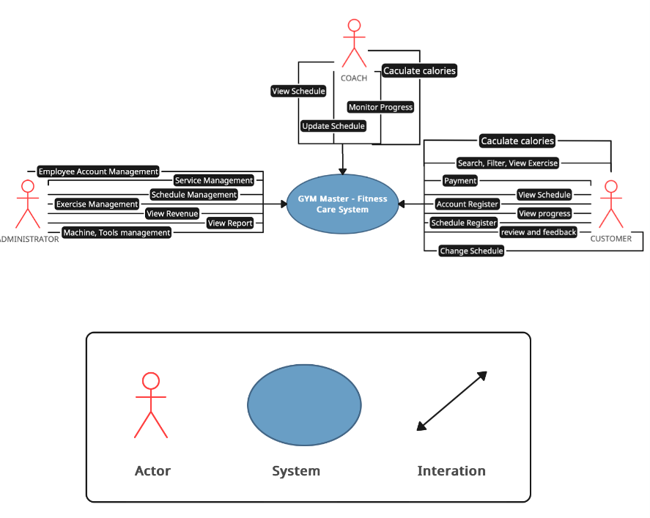

***Figure 2.6.1: System context overview***

### System context description

**The function of Administrator :**

* Employee Account Management.
* Service Management.
* Schedule Management.
* Exercise Management.
* View Revenue.
* View Report.
* Machine, Tools Management.

**The function of Coach :**

* View Schedule.
* Update Schedule.
* Monitor Progress.
* Calculate Calories.

**The function of Customer :**

* Search, View, Filter Exercise.
* Payment.
* View Schedule.
* View Progress.
* Account Register.
* Change Schedule.
* Schedule Register.
* Calculate Calories.

## Technical Constraints

**Client**

* Programming Language: JavaScript.
* Framework: ReactJS.
* Library: Material-UI, redux, reach router, axios,….
* Operating System: Windows.
* Code Editor: Visual Studio Code.
* Web Browser: Chrome, Firefox, Microsoft Edge

**Server**

* Programming Language: C#
* Framework: ASP.NET core
* Library: Entity Framework Core
* Database: MySQL
* Operating System: Windows.
* Code Editor: Visual Studio 2022.

**Business constraints**

* Resource: 5 people.

- Budget: 5000$.

* Time: The project must be completed within 3 months.

**Tool Management**

* Source code Version control: Git, Github.
* Document management: Google Driver.
* Manage task and project progress: Jira.
* Other: Postman, Figma, Zalo, Zoom

# Master Plan

## Scrum Process

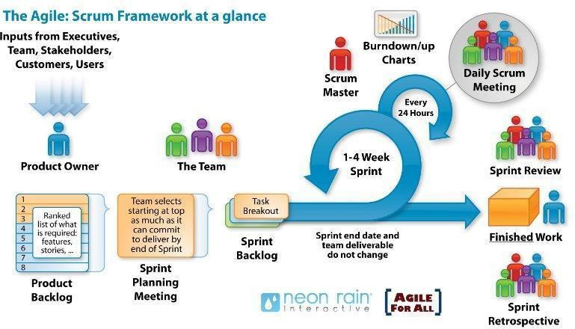

***Figure: General SCRUM Process***

* + - Scrum is an agile project management framework that emphasizes collaboration, iterative development, and rapid delivery of high-quality products. It enables teams to work in a flexible and adaptive manner, responding to changing requirements and customer feedback.
    - In Scrum, it is crucial for teams to possess this agility to effectively navigate challenges, make informed decisions, and drive innovation.
    - Mechanisms of empirical process control, where feedback loops that constitute the core management technique are used as opposed to traditional command-and- control management.
    - By breaking work into manageable iterations, teams can focus on delivering incremental value, improving efficiency, and maximizing their output. This approach boosts overall productivity and ensures a faster time to market.

# Organization Management

## Human Resource

* + - Team’s Information

|  |  |  |  |
| --- | --- | --- | --- |
| **Full Name** | **Phone** | **Email** | **Position** |
| Hoang, Nguyen Thai | 0914083388 | hoang.nguyenthai@axonactive.com | Mentor |
| Duy, Le Hai | 0383007180 | [lehaiduy2003@gmail.com](mailto:lehaiduy2003@gmail.com) | Team Leader |
| Thanh, Phan Van | 0123456789 | [thanhphanvan334455.3@gmail.com](mailto:thanhphanvan334455.3@gmail.com) | Team Member |
| An, Vo Thuy | 0123456789 | [vothuyan234@gmail.com](mailto:vothuyan234@gmail.com) | Team Member |
| Thu, Phan Nguyen Anh | 0123456789 | [anhthuphan0102@gmail.com](mailto:anhthuphan0102@gmail.com) | Team Member |
| Vu, Nguyen Thien Le | 0123456789 | nguyenthienlevu@gmail.com | Team Member |

# 

## Master plan

|  |  |  |  |  |
| --- | --- | --- | --- | --- |
| **NO** | **Task Name** | **Duration** | **Start** | **Finish** |
| **1** | **Start Up** | **11 days** | **14/01/2024** | **29/02/2024** |
| 1.1 | Project Kick Off Meeting | 1 day | 14/01/2024 | 14/01/2024 |
| 1.2 | Discuss about project ideal | 2 days | 15/01/2024 | 16/01/2024 |
| 1.3 | Create Document for project | 8 days | 22/02/2024 | 29/02/2024 |
| **2** | **Development** | **84 days** | **01/03/2024** | **23/05/2024** |
| 2.1 | Sprint 1 | 28 days | 01/03/2024 | 28/03/2024 |
| 2.2 | Sprint 2 | 28 days | 29/03/2024 | 25/04/2024 |
| 2.3 | Sprint 3 | 27 days | 26/04/2024 | 21/05/2024 |
| **3** | **Project’s Meeting** | **1 day** | 22/05/2024 | 22/05/2024 |
| **4** | **Final Release** | **1 day** | 23/05/2024 | 23/05/2024 |

# Cost Estimation

The following outlines the cost of completing all the identified components for the project.

|  |  |  |  |
| --- | --- | --- | --- |
| **No.** | **Phase** | **Milestone** | **Cost (4 hours/day) USD** |
| 1. | Start-up | STU | $300 |
| 2. | Development | SPR1 | $1400 |
| SPR2 | $1400 |
| SPR3 | $1400 |
| 3. | Other costs | OTH | $200 |
| 4. | Project’s Meeting | PM | $100 |
| 5. | Final Release | FR | $200 |
| 6. | **Total** | | **$5000** |

# Conclusion

In summary, the goal of the project is to develop a fitness support website system for the quality of gym users. The expected outcome is to optimize the workout process of the user, saving time and money, and improve the meal superiority and their health. Additionally, it will integrate web development technologies to create a user-friendly website, making it easy for users to interact.

# Project Constraints

|  |  |  |
| --- | --- | --- |
| **Constraint** | **Constraints Description** | **Guidelines for Acceptance** |
| **Economic** | N/A | Elements for consideration are design costs, production costs, maintenance costs, operating costs, and sales price |
| **Environmental** | N/A | The impact of the design on the environment as well as the impact of the environment (e.g.  Temperature range, humidity, vibration, electromagnetic interference immunity, and shock) on the design should be considered. Design for recycling and design to use recycled materials should also be considered |

|  |  |  |
| --- | --- | --- |
| **Public health, safety, and welfare** | N/A | Includes safety standards as well as the impact of the design on users (for example, electrical or physical hazards) |
| **Cultural** | Support for conducting virtual interviews according to culture-specific rules and restrictions. | Which cultural characteristics could influence the approach?  How do the designs from different cultures differ? |
| **Sustainability** | Ensure sustainability in the process of collecting, storing and using applicants' personal data.  Research and apply principles of sustainable development during system development and operation. | Refers to the sustainability of resources, including material, energy, supplies, manufacturing techniques, personnel, operation, and the need for additional infrastructure, as well as the sustainability of the design including reliability, lifetime, durability, reusability, maintainability. |

# References

|  |  |  |
| --- | --- | --- |
| **No** | **References** | **Document Information** |
| 1 | Scrum Model | <https://en.wikipedia.org/wiki/Scrum_(software_development)> |
| <https://www.atlassian.com/agile/scrum> |
| <https://www.digite.com/agile/scrum-methodology/> |
| [https://docs.microsoft.com/en-](https://docs.microsoft.com/en-us/azure/devops/boards/sprints/best-practices-scrum?view=azure-devops) [us/azure/devops/boards/sprints/b](https://docs.microsoft.com/en-us/azure/devops/boards/sprints/best-practices-scrum?view=azure-devops) [est-practices-](https://docs.microsoft.com/en-us/azure/devops/boards/sprints/best-practices-scrum?view=azure-devops) [scrum?view=azure-devops](https://docs.microsoft.com/en-us/azure/devops/boards/sprints/best-practices-scrum?view=azure-devops) |
| <https://www.scrum.org/resources/scrum-guide> |
| Essential Scrum - A Practical Guide to the Most Popular Agile Process by Kenneth S. Rubin |
| 2 | Technical | <https://learn.microsoft.com/en-us/aspnet/core/introduction-to-aspnet-core?view=aspnetcore-8.0> |
| <https://reactnative.dev/docs/getting-started> |
| <https://www.w3schools.com/mysql/mysql_intro.asp> |

# Requirements

|  |  |
| --- | --- |
| High-level Functional Requirements | 1. Tutorial for users |
| 2. schedule for member |
| 3. Hiring PT for member |
| 4. Calorie calculator |
| 5. Payment |

|  |  |
| --- | --- |
| Quality Attributes Requirements  (example related to issues: Ease  Use, Easy to Like, Easy to Learn, Easy to Understand, Easy to Buy / Yes, ...) | 2. User can use easily website without taking much time |
| 3. The processing functionalities are rational and straightforward to comprehend |
| 4. Adding a new feature can be accomplished with ease without requiring significant modification of the architecture |

|  |  |
| --- | --- |
| Operation Requirements  (related to issues: Speed, Accuracy, Performance, Stability, Load Resistance, Scalability, Safety, ...) | 1. Complete short tasks within a maximum time limit of 5 seconds per task |
| 2. Guarantee the responsibilities related to the security of user information |
| 3. Load the application fully within a maximum time of 10 seconds |
| 4. Compatible with all browsers |

|  |  |
| --- | --- |
| Environment & Operation Requirements  (related to issues: physical impacts on the environment, interact with relevant or existing systems, conditions for product commercialization, ...) | 1. Web browsers: Google Chrome latest version. |
| 4. Ensuring technical quality during the process of making a product or service available for sale |
| 5. Operating systems: Microsoft Windows 10 (11), Ubuntu 18.04 with SSD 512GB, RAM 8G |

|  |  |
| --- | --- |
| Requirements for Maintenance & Support | 1. Identifying and fixing underlying problems |
| 2. Consistently enhancing the ease of use, speed, and dependability of the software |
| 3. Resolving issues that have been reported by users or detected through monitoring processes |
| 4. Updating software to align with evolving business requirements |

|  |  |
| --- | --- |
| Security/ Safety Requirements  (related to issues: conditions of use / access to products, personal freedom, inspection, ...) | 1. Terms for users |
| 2. User information security |
| 3. Authenticate user information |

|  |  |
| --- | --- |
| Culture Requirements | 1. Vietnamese and language support |
| 2. Culture according to international standards |
| 3. Interface and policies suitable for many different cultures |

|  |  |
| --- | --- |
| Evaluate the complexity of engineering problems | 1. Involving wide-ranging or conflicting technical issues |
| 2. Having no obvious solution |
| 3. Addressing problems not encompassed by current standards and codes |
| 4. Involving diverse groups of stakeholders |
| 5. Including many component parts or sub-problems |
| 6. Involving multiple disciplines |
| 7. Having significant consequences in a range of contexts |

|  |  |
| --- | --- |
| Standard requirements | 1. Code standard. (HTML,CSS, JS) |
| 2. Design standard. (design patterns, object-oriented analysis and design,…). |
| 3. IEEE (1058, 1540, 830, 1016, 829, 1012, 1008) |
| 4. ISO/IEC/IEEE 12207:2017 (TCVN 10539:2014); ISO/IEC 25051:2006(TCVN 10540:2014); |
| 5. Other standards. (related to specific topics) |